Name : Chand Kavar Enroll: 230801313
Division:C5 Roll Number : 31
Unit 1
1. Create web form to print hello world.
Code:
<%@ Page Language="C#" AutoEventWireup="true"
CodeBehind="p1.aspx.cs" Inherits="_230801313.Unit1.p1" %> <!DOCTYPE html>
<html xmlns="http://www.w3.org/1999/xhtml">
<head runat="server">
<title></title>
</head>
<body>
<form id="form1" runat="server">
<div>
</div>
</form>
</body>
</html>
Output:
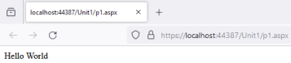1
Enroll: 230801313 Roll Number : 31 Name : Chand Kavar Division:C5
2. Create web form to print hello world with your name.
Code:
using System;
using System.Collections.Generic;
using System.Linq;
using System.Web;
using System.Web.UI;
using System.Web.UI.WebControls;
namespace _230801313.Unit1
{
public partial class p2 : System.Web.UI.Page
{
protected void Page_Load(object sender, EventArgs e) {
Response.Write("Hello- Chand");
}
}
}
Output:
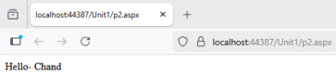2
Enroll: 230801313 Roll Number : 31 Name : Chand Kavar Division:C5
3. Create web form to print your name with address in new line. Code:
using System;
using System.Collections.Generic;
using System.Linq;
using System.Web;
using System.Web.UI;
using System.Web.UI.WebControls;
namespace _230801313.Unit1
{
public partial class p3 : System.Web.UI.Page {
protected void Page_Load(object sender, EventArgs e) {
Response.Write("Chand<br>Rajkot, Gujarat"); }
}
}
Output:
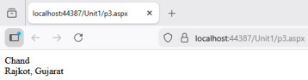3
Enroll: 230801313 Roll Number : 31 Name : Chand Kavar Division:C5
4. Create web form to print any digit.
Code:
using System;
using System.Collections.Generic;
using System.Linq;
using System.Web;
using System.Web.UI;
using System.Web.UI.WebControls;
namespace _230801313.Unit1
{
public partial class p4 : System.Web.UI.Page {
protected void Page_Load(object sender, EventArgs e) {
Response.Write("Digit is: 7");
}
}
}
Output:
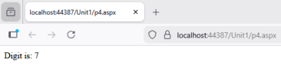4
Enroll: 230801313 Roll Number : 31 Name : Chand Kavar Division:C5
5. Create web form to print your name in label.
Code:
using System;
using System.Collections.Generic;
using System.Linq;
using System.Web;
using System.Web.UI;
using System.Web.UI.WebControls;
namespace _230801313.Unit1
{
public partial class p5 : System.Web.UI.Page
{
protected void btnShow_Click(object sender, EventArgs e) {
lblName.Text = "My Name is Chand";
}
}
}
Output:
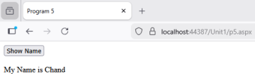5
Enroll: 230801313 Roll Number : 31 Name : Chand Kavar Division:C5
6. Create web form to print any digit in label.
Code:
using System;
using System.Collections.Generic;
using System.Linq;
using System.Web;
using System.Web.UI;
using System.Web.UI.WebControls;
namespace _230801313.Unit1
{
public partial class p6 : System.Web.UI.Page
{
protected void btnShow_Click(object sender, EventArgs e) {
lblDigit.Text = "Digit is: 7";
}
}
}
Output:
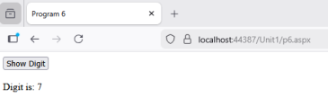6
Enroll: 230801313 Roll Number : 31 Name : Chand Kavar Division:C5
7. Create web form to print sum of two variable.
Code:
using System;
using System.Collections.Generic;
using System.Linq;
using System.Web;
using System.Web.UI;
using System.Web.UI.WebControls;
namespace _230801313.Unit1
{
public partial class p7 : System.Web.UI.Page {
protected void btnSum_Click(object sender, EventArgs e) {
int a = int.Parse(txtA.Text);
int b = int.Parse(txtB.Text);
Response.Write("Sum of two numbers = " + (a + b)); }
}
}
Output:
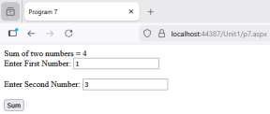
7
Enroll: 230801313 Roll Number : 31 Name : Chand Kavar Division:C5
8. Create web form to print sum of two variable in label.
code:
using System;
using System.Collections.Generic;
using System.Linq;
using System.Web;
using System.Web.UI;
using System.Web.UI.WebControls;
namespace _230801313.Unit1
{
public partial class p8 : System.Web.UI.Page {
protected void btnSum_Click(object sender, EventArgs e) {
int a = int.Parse(txtA.Text);
int b = int.Parse(txtB.Text);
lblResult.Text = "Sum of two numbers = " + (a + b); }
}
}
Output:
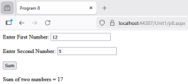
8
Enroll: 230801313 Roll Number : 31 Name : Chand Kavar Division:C5
9. Create web form to print weather number is even/odd.
code:
using System;
using System.Collections.Generic;
using System.Linq;
using System.Web;
using System.Web.UI;
using System.Web.UI.WebControls;
namespace _230801313.Unit1
{
public partial class p9 : System.Web.UI.Page
{
protected void btnCheck_Click(object sender, EventArgs e) {
int number = int.Parse(txtNumber.Text);
if (number % 2 == 0)
Response.Write("The number " + number + " is Even"); else
Response.Write("The number " + number + " is Odd"); }
}
}
Output:
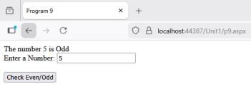9
Enroll: 230801313 Roll Number : 31 Name : Chand Kavar Division:C5
10. Create web form to print weather number is positive/negative or zero. code:
using System;
using System.Collections.Generic;
using System.Linq;
using System.Web;
using System.Web.UI;
using System.Web.UI.WebControls;
namespace _230801313.Unit1
{
public partial class p10 : System.Web.UI.Page {
protected void btnCheck_Click(object sender, EventArgs e) {
int number = int.Parse(txtNumber.Text);
if (number > 0)
Response.Write("The number " + number + " is Positive");
else if (number < 0)
Response.Write("The number " + number + " is Negative");
else
Response.Write("The number is Zero"); }
}
}
Output:
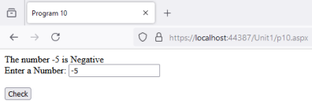10
Enroll: 230801313 Roll Number : 31 Name : Chand Kavar Division:C5
11. Create web form to print weather user is eligible for a vote or not. code:
using System;
using System.Collections.Generic;
using System.Linq;
using System.Web;
using System.Web.UI;
using System.Web.UI.WebControls;
namespace _230801313.Unit1
{
public partial class p11 : System.Web.UI.Page {
protected void btnCheck_Click(object sender, EventArgs e) {
int age = int.Parse(txtAge.Text);
if (age >= 18)
Response.Write("User is Eligible for Vote"); else
Response.Write("User is Not Eligible for Vote"); }
}
}
Output:
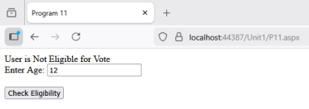11
Enroll: 230801313 Roll Number : 31 Name : Chand Kavar Division:C5
12. Create web form to Swap two numbers
Code:
using System;
using System.Collections.Generic;
using System.Linq;
using System.Web;
using System.Web.UI;
using System.Web.UI.WebControls;
namespace _230801313.Unit1
{
public partial class p12 : System.Web.UI.Page {
protected void btnSwap_Click(object sender, EventArgs e) {
int a = int.Parse(txtA.Text);
int b = int.Parse(txtB.Text);
int temp;
temp = a;
a = b;
b = temp;
Response.Write("After Swap <br/>");
Response.Write("First Number: " + a + "<br/>"); Response.Write("Second Number: " + b); }
}
}
Output:
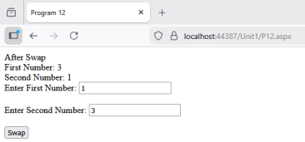12
Enroll: 230801313 Roll Number : 31 Name : Chand Kavar Division:C5
13. Create web form to print 1 to 10 number using for, while and do while loop.
Code:
using System;
using System;
using System.Collections.Generic;
using System.Linq;
using System.Web;
using System.Web.UI;
using System.Web.UI.WebControls;
namespace _230801313.Unit1
{
public partial class p13 : System.Web.UI.Page
{
protected void btnFor_Click(object sender, EventArgs e) {
Response.Write("For Loop:<br/>");
for (int i = 1; i <= 10; i++)
{
Response.Write(i + "<br/>");
}
}
protected void btnWhile_Click(object sender, EventArgs e) {
Response.Write("While Loop:<br/>");
int i = 1;
while (i <= 10)
{
Response.Write(i + "<br/>");
i++;
}
}
protected void btnDoWhile_Click(object sender, EventArgs e) {
Response.Write("Do While Loop:<br/>");
int i = 1;
do
{
Response.Write(i + "<br/>");
i++;
} while (i <= 10);
}
}
}
13
Enroll: 230801313 Roll Number : 31 Name : Chand Kavar Division:C5 Output:
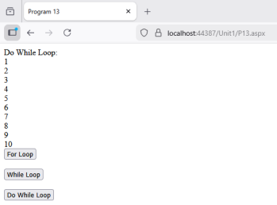

14. Create web form to print 10 to 1 number using for, while and do while loop.
Code:
using System;
using System.Collections.Generic;
using System.Linq;
using System.Web;
using System.Web.UI;
using System.Web.UI.WebControls;
namespace _230801313.Unit1
{
public partial class p14 : System.Web.UI.Page
{
protected void btnFor_Click(object sender, EventArgs e) {
Response.Write("For Loop:<br/>");
for (int i = 10; i >= 1; i--)
{
Response.Write(i + "<br/>");
}
}
protected void btnWhile_Click(object sender, EventArgs e) {
Response.Write("While Loop:<br/>");
int i = 10;
while (i >= 1)
{
Response.Write(i + "<br/>");
i--;
}
}
protected void btnDoWhile_Click(object sender, EventArgs e) {
Response.Write("Do While Loop:<br/>");
int i = 10;
do
{
Response.Write(i + "<br/>");
i--;
} while (i >= 1);
}
}
}
Output:
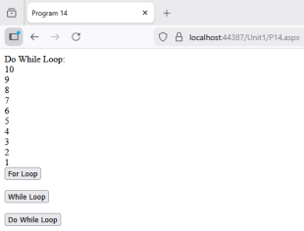

15. Create web form to print days according our choice by using switch case. Code:
using System;
using System.Collections.Generic;
using System.Linq;
using System.Web;
using System.Web.UI;
using System.Web.UI.WebControls;
namespace _230801313.Unit1
{
public partial class p15 : System.Web.UI.Page
{
protected void btnShow_Click(object sender, EventArgs e) {
int day = int.Parse(txtDay.Text);
switch (day)
{
case 1:
Response.Write("Sunday");
break;
case 2:
Response.Write("Monday");
break;
case 3:
Response.Write("Tuesday");
break;
case 4:
Response.Write("Wednesday");
break;
case 5:
Response.Write("Thursday");
break;
case 6:
Response.Write("Friday");
break;
case 7:
Response.Write("Saturday");
break;
default:
Response.Write("Invalid Day Number! Please enter 1-7.");
break;
}
}
}
}
Output:
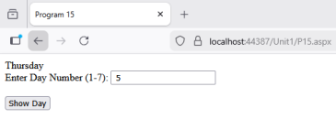18

16. Create Method for sum of two variable (Method overloading AND Method Overridding).
Code:
using System;
using System.Collections.Generic;
using System.Linq;
using System.Web;
using System.Web.UI;
using System.Web.UI.WebControls;
namespace _230801313.Unit1
{
public class CalculatorBase
{
public virtual int Sum(int a, int b)
{
return a + b;
}
}
public class CalculatorDerived : CalculatorBase
{
public override int Sum(int a, int b)
{
return a + b + 0;
}
public int Sum(int a, int b, int c)
{
return a + b + c;
}
}
public partial class p16 : System.Web.UI.Page
{
protected void btnSum_Click(object sender, EventArgs e) {
CalculatorDerived calc = new CalculatorDerived(); int sum2 = calc.Sum(5, 10); // Overridden method
int sum3 = calc.Sum(5, 10, 15); // Overloaded method
lblResult.Text = "Sum of 2 numbers: " + sum2 + "<br/>" + "Sum of 3 numbers: " + sum3; }
}
19
Enroll: 230801313 Roll Number : 31 Name : Chand Kavar Division:C5
}
Output:

17. When Click on Button display alert dialog box .
Code:
using System;
using System.Collections.Generic;
using System.Linq;
using System.Web;
using System.Web.UI;
using System.Web.UI.WebControls;
namespace _230801313.Unit1
{
public partial class p17 : System.Web.UI.Page {
protected void btnAlert_Click(object sender, EventArgs e) {
string message = "Hello! This is an alert box."; ClientScript.RegisterStartupScript(this.GetType(), "alert", "alert('" + message + "');", true);
}
}
}
Output:

18
Code:
Lb.dll:
using System;
usingSystem.Collections.Generic;
usingSystem.Linq;
usingSystem.Text;
usingSystem.Threading.Tasks;
namespace lb
{
publicclassClass1
{
publicstaticint sum (int a , int b)
{
return a + b;
}
}
}
.aspx:
<%@ Page Language="C#" AutoEventWireup="true"
CodeBehind="p18.aspx.cs" Inherits="_230801313.Unit1.p18" %>
<!DOCTYPE html>
<html xmlns="http://www.w3.org/1999/xhtml">
<head runat="server">
<title>Program 18</title>
</head>
<body>
<form id="form1" runat="server">
<div>
<asp:Button ID="btnCalculate" runat="server" Text="Calculate Sum" OnClick="btnCalculate_Click"></asp:Button> <br /><br />
<asp:Label ID="lblResult" runat="server"></asp:Label> </div>
</form>
</body>
</html>
.cs:
using System;
using System.Collections.Generic;
using System.Linq;using System.Web;
using System.Web.UI;
using System.Web.UI.WebControls;
namespace _230801313.Unit1
{
public partial class p18 : System.Web.UI.Page
{
protected void btnCalculate_Click(object sender, EventArgs e)
{
Calculator calc = new Calculator();
int result = calc.Sum(10, 20); //
lblResult.Text = "Sum from Class Library: " + result; }
}
}
Output:
23

